A

PROJECT REPORT

ON

**APPLICATIONS OF BLOCKCHAIN FOR SECURE BANK TRANSACTIONS**

SUBMITTED TO THE

SAVITRIBAI PHULE PUNE UNIVERSITY

IN THE PARTIAL FULFILLMENT FOR THE AWARD OF THE DEGREE

OF

**“BACHELOR OF ENGINEERING IN ARTIFICIAL INTELLIGENCE AND DATA SCIENCE”**

BY

Shivam Patil Roll No. B190532058

Gaurang Mhatre Roll No. B190532050

Prathmesh Phadtre Roll No. B190532061

Pratik Aher Roll No. B190532001

UNDER THE GUIDANCE OF

Prof. Anuja Garande



Department of Artificial Intelligence and Data Science

Zeal Education Society’s

**ZEAL COLLEGE OF ENGINEERING AND RESEARCH**

NARHE, PUNE-411041

2023-2024



**CERTIFICATE**

This is to certify that the project report entitled **“ON**

**APPLICATIONS OF BLOCKCHAIN FOR SECURE BANK TRANSACTIONS ”**

SUBMITTED BY

Shivam Patil Roll No. B190532058

Gaurang Mhatre Roll No. B190532050

Prathmesh Phadtre Roll No. B190532061

Pratik Aher Roll No. B190532001

is a bonafide work carried out by them under the supervision of **Prof. Anuja Garande** and it is approved for the partial fulfillment of the requirement of Savitribai Phule Pune University for the award of the Degree of Bachelor of Engineering(Artificial Intelligence and Data Science). This Project report has not been earlier submitted to any other Institute or University for the award of any degree or diploma.

Prof. Anuja Garande Prof. Dikshendra Sarpate

Internal Guide Head of departmentDept of Artificial Intelligence Dept of Artificial Intelligence and Data Science and Data Science

External Examiner Dr.A.M.Kate Principal Zeal College Of Engg. and Research

Date:

Place: Pune

# ACKNOWLEDGEMENT

Firstly, we take this privilege to thank sincerely of our college management in extending their incomparable support and facilities for the completion of our project stage-1 in the department.

We would like to express our sincere gratitude to our project guide **Prof. Anuja Garande**,Assistant professor, Department of Artificial Intelligence and Data Science, for his valuable guidance and suggestions to complete our project stage-1. We are thankful for his valuable feedback and suggestions for the completion of this work.

We take this immense pleasure to thank our beloved Head of the Department, **Prof. Dikshendra Sarpate,** Department of Artificial Intelligence and Data Science, for his valuable guidance, support and encouragement and permitting us to use resources in the department.

We are extremely thankful to our Principal **Dr. Ajit Kate** for his support and guidance and giving permission to use resources in the department and college.

Last but not the least; we are very thankful to all the teaching and non-teaching staff members in the department for their kind cooperation and support given throughout the completion of our project..

Shivam Patil Roll No. B190532058

Gaurang Mhatre Roll No. B190532050

Prathmesh Phadtre Roll No. B190532061

Pratik Aher Roll No. B190532001

# 

# LIST OF ABBREVIATIONS

* POW : Proof of Work
* POS : Proof of Stake
* POB : Proof of Burn
* PBFT : Practical Byzantine Fault Tolerance
* POC : Proof of Capacity
* POA :Proof of Authority
* DPOS : Delegated Proof of Stake
* QR : Quick-response code

# LIST OF TABLES

|  |  |  |
| --- | --- | --- |
| **Table. No** | **Figure Name** | **Page No** |
| 7.2 | Plagiarism Report | 49 |
| 7.3 | Detailed Test Cases | 50 |

# 

# LIST OF FIGURES

|  |  |  |
| --- | --- | --- |
| **Fig. No** | **Figure Name** |  |
| 1.1 | Block Diagram |  |
| 1.2 | Working of Blockchain |  |
| 4.1 | Software Architectural design |  |
| 4.2 | DFD |  |
| 5.1 | Class Diagram |  |
| 5.2 | Use Case Diagram |  |
| 5.3 | Activity Diagram |  |
| 5.4 | Sequence Diagram |  |
| 7.3 | Result on uploaded image |  |

# 

# ABSTRACT

# When payment systems were first computerized, the underlying processes were not significantly changed. While records and ledgers have been converted from paper to electronic form, the basic structure of centralized payment systems remained. The Indian banking industry today is struggling with issues such as rising costs of operations, increasing susceptibility to fraudulent attacks on centralized servers, and challenges in ensuring transparency. To address these issues, our research explores the implementation of a blockchain-based banking transaction system.

# This proposed system leverages blockchain technology's decentralized ledger to enhance security, transparency, and efficiency in banking transactions. By utilizing smart contracts, the system automates transaction processing, ensuring that predefined conditions are met before executing transactions. This automation minimizes human intervention, reducing the risk of errors and fraud while accelerating transaction times. Moreover, the immutable nature of blockchain records ensures a tamper-proof and transparent transaction history, thereby increasing trust among stakeholders.

# Additionally, our approach aims to create a application built on top of a Blockchain-based architecture. This design addresses the current challenges faced by conventional financial systems, such as lack of transparency, delays in fund settlement, and vulnerability to fraudulent activities. Blockchain's cryptographic features protect sensitive financial data from unauthorized access and cyber threats, providing a robust security framework crucial for the banking sector.

# In conclusion, the adoption of a blockchain-based banking transaction system represents a significant advancement for the banking industry. By improving security, transparency, and efficiency, and reducing operational costs, blockchain technology has the potential to resolve many of the issues inherent in traditional banking systems. This paper highlights the critical aspects and benefits of blockchain implementation in banking, paving the way for future research and development in this domain.

# TABLE OF CONTENTS

|  |  |  |  |  |
| --- | --- | --- | --- | --- |
| **Sr. No** | **Chapter** | | | **Page No.** |
| **1** | **Introduction** | | | 10-12 |
|  | 1.1 | Introduction to Project | | 10 |
|  | 1.2 | Problem Statement | | 11 |
|  | 1.3 | Motivation behind the Project | | 11 |
|  | 1.4 | Objectives of the Project | | 12 |
|  | 1.5 | Overview of the Project | | 12 |
| **2** | **Literature Survey** | | | 13-19 |
|  | 2.1 | Introduction | | 13 |
|  | 2.2 | Related work | | 13 |
|  | 2.3 | Existing Systems | | 19 |
| **3** | **Requirement Analysis** | | | 20-22 |
|  | 3.1 | Problem Statement | | 20 |
|  | 3.2 | Requirement Specification | | 20 |
|  |  | 3.2.1 | Functional Requirements | 20 |
|  |  | 3.2.2 | Non-functional Requirements | 21 |
|  | 3.3 | Project Requirement Specification | | 21 |
|  |  | 3.3.1 | Software Requirements | 21 |
|  |  | 3.3.2 | Hardware Requirements | 22 |
| **4** | **System Architecture** | | | 23-27 |
|  | 4.1 | System Flow Architecture | | 23 |
|  | 4.2 | DFD Diagram | | 26 |
| **5** | **Design** | | | 28-33 |
|  | 5.1 | Use case Diagram | | 28 |
|  | 5.2 | Activity Diagram | | 30 |
|  | 5.3 | Sequence Diagram | | 32 |
| **6** | **System Implementation** | | | 34-38 |
|  | 6.1 | System Overview | | 34 |
|  | 6.2 | Modules | | 36 |
| **7** | **Results and Evaluation** | | | 39-46 |
|  | 7.1 | Results | | 39 |
|  | 7.2 | Outputs | | 40 |
|  |  | | |  |

# 

# CHAPTER 1

# INTRODUCTION

## 1.1 Introduction

When payment systems were first computerized, the underlying processes were not significantly changed. While records and ledgers have been converted from paper to electronic form, the basic structure of centralized payment systems remained.

Blockchain technology introduces a fundamentally different, decentralized structure into payment systems, with cryptography rather than a central clearing institution as to its very basis, and without intermediaries such as banks.

1.2 **Problem Statement**

To overcome the drawbacks of conventional financial systems, like lack of transparency, higher security risks because of centralized servers, delays in fund settlements due to complex internal processes, also the issue of higher transaction costs due to a global customer base.

1.3 **Motivation Behind The Project**

The Indian banking industry today is struggling with issues such as rising costs of operations, increasing susceptibility to fraudulent attacks on centralized servers, and challenges in ensuring transparency.

All this, primarily because most of the banking transactions may require intensive manual processing and documentation, involve costly intermediaries, and are time-consuming as these transactions need to be validated by various participants at various points in time causing delay thereby resulting in almost no fraud-proof real-time solution.

## 1.4 Objectives Of The Project

## To create a decentralized blockchain-based banking system that can bring in transparency, proper security methods for user authentication and in turn reduce the transaction settlement time. The banking application will be based on blockchain technology providing features such as transactions, token requests, QR payments, etc.

## 1.5 Overview Of The Project

# The goal is to create a web 3.0 compliant application built on top of a cloud-based architecture . It's a virtualization application that aims to provide a distributed system through which a user can transmit a token and also features to ease out its transaction process will also be provided.

### **1.5.1 What Is a Blockchain?**

A blockchain is a distributed database or ledger shared among a computer network's nodes. They are best known for their crucial role in cryptocurrency systems for maintaining a secure and decentralized record of transactions, but they are not limited to cryptocurrency uses. Blockchains can be used to make data in any industry immutable—the term used to describe the inability to be altered.

Because there is no way to change a block, the only trust needed is at the point where a user or program enters data. This aspect reduces the need for trusted third parties, which are usually auditors or other humans that add costs and make mistakes.

Since Bitcoin's introduction in 2009, blockchain uses have exploded via the creation of various cryptocurrencies, decentralized finance (DeFi) applications, non-fungible tokens (NFTs), and smart contracts.

**How Does a Blockchain Work?**

You might be familiar with spreadsheets or databases. A blockchain is somewhat similar because it is a database where information is entered and stored. But the key difference between a traditional database or spreadsheet and a blockchain is how the data is structured and accessed.A blockchain consists of programs called scripts that conduct the tasks you usually would in a database: Entering and accessing information and saving and storing it somewhere. A blockchain is distributed, which means multiple copies are saved on many machines, and they must all match for it to be valid.

The blockchain collects transaction information and enters it into a block, like a cell in a spreadsheet containing information. Once it is full, the information is run through an encryption algorithm, which creates a hexadecimal number called the hash.The hash is then entered into the following block header and encrypted with the other information in the block. This creates a series of blocks that are chained together.

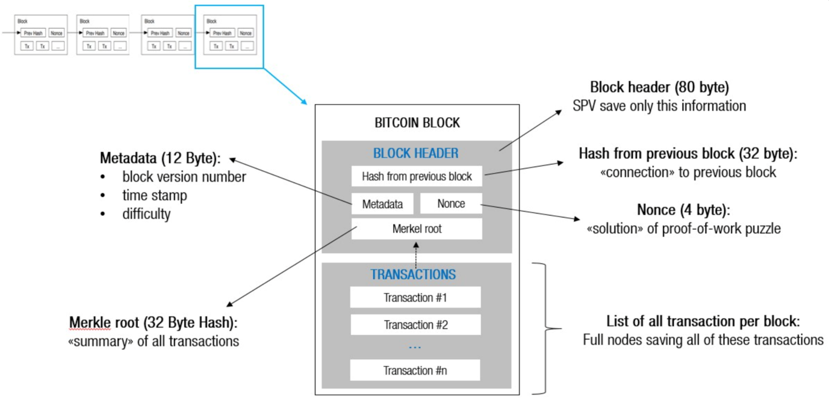

Fig1.1 Block Diagram

**Transaction Process**

Transactions follow a specific process, depending on the blockchain they are taking place on. For example, on Bitcoin's blockchain, if you initiate a transaction using your cryptocurrency wallet—the application that provides an interface for the blockchain—it starts a sequence of events.In Bitcoin, your transaction is sent to a memory pool, where it is stored and queued until a miner or validator picks it up. Once it is entered into a block and the block fills up with transactions, it is closed and encrypted using an encryption algorithm. Then, the mining begins.

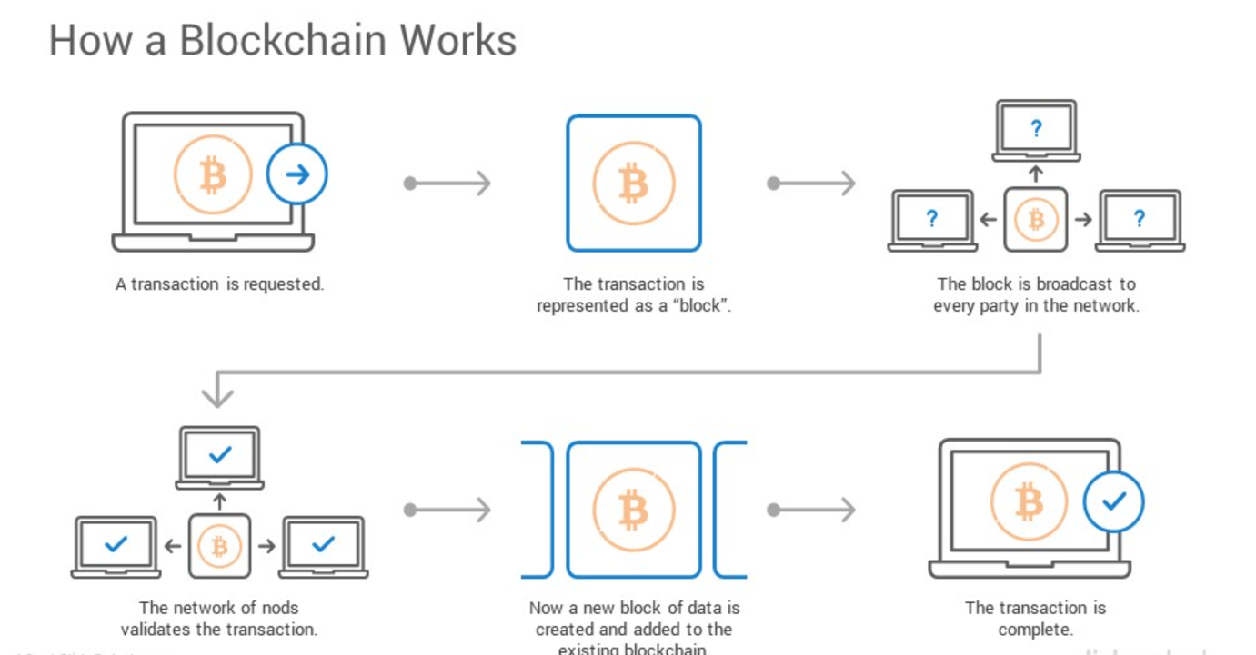

Fig 1.2 Working of Blockchain

**Consensus Algorithm**

Generally, there is no central authority or decision maker in network systems with multiple distributed nodes in a decentralized fashion. Therefore, decentralized network systems require a means to make decisions and achieve overall system reliability. As a result, a mechanism has been designed to coordinate the system's processes to agree on data value and how that will be used in the system. This mechanism is referred to as a consensus algorithm.

Recently, the term consensus algorithm has become one of the buzzwords used most commonly in blockchain. Blockchain as a decentralized technology seeks to find a means to make decisions without tampering with the system's security. Therefore, this is where the consensus algorithm comes into play. The consensus algorithm was designed as a model to reach a final agreement among the peers in a particular blockchain network.

**How a consensus algorithm works**

A consensus algorithm is a mechanism or protocol employed in a distributed decentralized network for reaching an agreement on activities or transactions being carried out in the network. It ensures these network activities are done in a secure and reliable manner, therefore establishing trust among peers in the network. The consensus algorithm in blockchain networks validates and verifies transactions that are stored in blocks. Before a block of transactions is added to the blockchain, it must be validated and verified to have happened and to be correct. This is done to ensure that the network remains secure, reliable, and immutable.

**The need for a consensus algorithm**

The consensus algorithm is a core part of the blockchain network because it achieves agreement, trust, and security across a decentralized network. Consensus algorithms are also designed to prevent the 51% attack on a network. This means that a particular validator cannot have control of the network.

**Here are a few reasons why a consensus algorithm is needed**:

* Unified agreement: A consensus algorithm makes it easy and secure to reach an agreement on the activities and state of the network.
* Prevent double-spending: Double spending means spending a digital currency twice. A consensus algorithm is designed to ensure that only transactions that are verified and valid are added to the blockchain.
* Fair and equitable: Consensus algorithms align with the open-source feature of blockchain by allowing anyone to join and participate in the network.
* Reliable: Another major need for the consensus algorithm is to ensure the reliability of the network. It also ensures the network is fault-tolerant and resistant to threat attacks.

**Types of consensus algorithms**

The consensus algorithm can be designed with different functionalities while maintaining the basic objective: to reach an agreement and ensure the reliability of the network. The following is a list of the different types of consensus algorithms:

* Proof of Work
* Proof of Stake
* Proof of Burn
* Practical Byzantine Fault Tolerance (PBFT)
* Proof of Elapsed Time
* Proof of Capacity
* Proof of Authority (PoA)
* Delegated Proof of Stake (DPoS)
* Proof of Activity
* Proof of Weight

The two most commonly used consensus algorithms are the Proof of Work and the Proof of Stake. Let's look into these two major types in detail:

**Proof of Work (PoW):**

The validators in this type of consensus algorithm are called miners. For a new block of transactions to be created and added to the blockchain, the miners are required to solve a complex mathematical puzzle that involves a lot of computational power. The first miner to solve the puzzle gets to create the next block and add it to the blockchain, and this process is known as mining. In addition, a certain amount of the network’s native coin is given to the first miner as a block reward.

In a nutshell, the mathematical puzzle acts as the consensus metric in ensuring the network is secure, reliable, and trusted. Examples of blockchain networks that use this consensus algorithm include Bitcoin, Ethereum, and more.

**Proof of Stake (PoS**):

This consensus algorithm was designed as an alternative to Proof of Work because of the large computational power and hardware requirements of Proof of Work.

Here, the validators participate in the validation and verification of transactions by locking up some of their coins in a wallet as their stake. The validator with the highest stake is selected to create a new block and add it to the blockchain. This validator receives transaction fees as a reward. Examples of blockchain networks that use Proof of Stake include Ethereum 2.0, Cardano, Polygon, and others.

A stake is value/money we bet on a certain outcome. The process is called staking.

A more particular meaning of stake will be defined later on.

**Why Proof-of-Stake:**

Before proof of stake, the most popular way to achieve distributed consensus was through Proof-of-Work (implemented in Bitcoin). But Proof-of-Work is quite energy(electrical energy in mining a bitcoin) intensive. So, a proof-of-work based consensus mechanism increases an entity’s chances of mining a new block if it has more computation resources. Apart from the upper two points, there are other weaknesses of a PoW based consensus mechanism which we will discuss later on. In such a scenario, a Proof-of-Stake based mechanism holds merit.

**What is Proof-of-Stake:**

As understandable from the name, nodes on a network stake an amount of cryptocurrency to become candidates to validate the new block and earn the fee from it. Then, an algorithm chooses from the pool of candidates the node which will validate the new block. This selection algorithm combines the quantity of stake (amount of cryptocurrency) with other factors (like coin-age based selection, randomization process) to make the selection fair to everyone on the network.

**A typical PoS based mechanism workflow:**

* Nodes make transactions. The PoS algorithm puts all these transactions in a pool.
* All the nodes contending to become validator for the next block raise a stake. This stake is combined with other factors like ‘coin-age’ or ‘randomized block selection’ to select the validator.
* The validator verifies all the transactions and publishes the block. His stake still remains locked and the forging reward is also not granted yet. This is so that the nodes on the network can ‘OK’ the new block.
* If the block is ‘OK’-ed, the validator gets the stake back and the reward too. If the algorithm is using a coin-age based mechanism to select validators, the validator for the current block’s has its coin-age reset to 0. This puts him in a low-priority for the next validator election.
* If the block is not verified by other nodes on the network, the validator loses its stake and is marked as ‘bad’ by the algorithm. The process again starts from step 1 to forge the new block.

**Advantages of PoS:**

* Energy-efficient:

As all the nodes are not competing against each other to attach a new block to the blockchain, energy is saved. Also, no problem has to be solved( as in case of Proof-of-Work system) thus saving the energy.

* Decentralization:

In blockchains like Bitcoin(Proof of Work system to achieve distributed consensus), an extra incentive of exponential rewards are in place to join a mining pool leading to a more centralized nature of blockchain. In the case of a Proof-of-Stake based system(like Peercoin), rewards are proportional(linear) to the amount of stake. So, it provides absolutely no extra edge to join a mining pool; thus promoting decentralization.

* Security:

A person attempting to attack a network will have to own 51% of the stakes(pretty expensive). This leads to a secure network.

Weakness of a PoS mechanism:

* Large stake validators:

If a group of validator candidates combine and own a significant share of total cryptocurrency, they will have more chances of becoming validators. Increased chances lead to increased selections, which lead to more and more forging reward earning, which lead to owning a huge currency share. This can cause the network to become centralized over time.

* New technology:

PoS is still relatively new. Research is ongoing to find flaws, fix them and making it viable for a live network with actual currency transactions.

* The ‘Nothing at Stake’ problem:

This problem describes the little to no disadvantage to the nodes in case they support multiple blockchains in the event of a blockchain split(blockchain forking). In the worst-case scenario, every fork will lead to multiple blockchains and validators will work and the nodes in the network will never achieve consensus.

**Summary**

Most banking transactions may require intensive manual processing and documentation, involve costly intermediaries, and are time-consuming as these transactions need to be validated by various participants at various points in time causing delay thereby resulting in almost no fraud-proof real-time solution.

Blockchain technology introduces a fundamentally different, decentralized structure into payment systems, with cryptography rather than a central clearing institution as to its very basis, and without intermediaries such as banks. The Indian banking industry today is struggling with issues such as rising costs of operations, increasing susceptibility to fraudulent attacks on centralized servers, and challenges in ensuring transparency.

# CHAPTER 2

# BACKGROUND AND LITERATURE SURVEY

## 2.1 Introduction

Blockchain technology is a core, underlying technology with promising application prospects in the banking industry. On one hand, the banking industry is facing the impact of interest rate liberalization and profit decline caused by the narrowing interest-rate spread.

## 2.2 Related Work

|  |  |  |  |
| --- | --- | --- | --- |
| **SURVEY** | **AUTHOR** | **YEAR** | **EXPLANATION** |
| **Blockchain application and outlook in the banking industry** | Ye Guo and  Chen Liang | 2016 | In this paper, Ye Guo and Chen Liang had presented their idea by examining the Chinese Banking sector. They said that Blockchains could revolutionize the underlying technology of the payment clearing and credit information systems in banks, thus upgrading and transforming them.. |
| **Blockchain Technology and the Financial Services Market,** | Krause, et al | 2017 | The technology could remove trusted third parties, decrease costs and ultimately increase profits for various players within the industry. Although public blockchains provide high data security and transparency, they are relatively slow if a high number of transactions need to be processed. In the field of payment transactions, it could reshape the current correspondent banking processes and lead to cost savings. |
| **BlockChain & Financial Inclusion** | Prof.Reena Aggrawal | 2017 | A world bank report, 2014 said that around 2 billion individuals who don't have access to banking services. From which 20.6% of unbanked individuals are from India. This paper discussed that blockchain can play a significant role in the financial Inclusion process. It says that F.I. using blockchain for internal and cross-border payments can lower costs, shorten settlement time, and provide a better user experience |
| **Blockchain in banking** | Deloitte | 2017 | As transactions are being done up on Blockchain, Blockchain DLT and all the relevant parties can view and verify the processes. There is only one source of truth and transactions cannot be processed further unless all the relevant parties agree and authenticate it. |

## 2.3 Existing Systems

**Existing Systems in the Conventional Financial System**

Conventional financial systems encompass various infrastructure and processes that facilitate banking and financial transactions. These systems are critical for the functioning of the global economy, providing the backbone for various financial activities, including payments, settlements, and interbank transactions. Here are some of the key existing systems:

**1. SWIFT (Society for Worldwide Interbank Financial Telecommunication)**

SWIFT is the dominant global messaging network used by banks and financial institutions for international money transfers. It standardizes communication protocols, ensuring secure and reliable transmission of payment instructions across borders.

**2. ACH (Automated Clearing House)**

ACH is an electronic network for processing large volumes of credit and debit transactions in batches. It is primarily used in the United States for direct deposits, payroll, and vendor payments.

**3. RTGS (Real-Time Gross Settlement)**

RTGS systems process high-value transactions individually in real time, without netting debits with credits. These systems are crucial for the immediate transfer of funds and are typically operated by central banks.

**4. CHIPS (Clearing House Interbank Payments System)**

CHIPS is a private clearinghouse for large-value transactions in the United States. It provides netting and settlement services for financial institutions, reducing liquidity needs through a net settlement process.

**Pros and cons of the conventional financial system**

**Pros**

* Higher customer trust.
* Transactions are private to the bank and customer.
* Interests in deposits.

**Cons**

* A centralized approach increases the security risk
* Lack of transparency
* Increased transactional cost due to higher internal processes.

**Issues/observations from the investigation**

After studying the conventional financial system we observed that customer trust is much higher than in the newer blockchain-based financial system because of its complex nature of working. We also discovered that the cost of establishment of the conventional banking system is much higher than it will take to set up a blockchain-based decentralized banking system.

# 

# CHAPTER 3

# REQUIREMENT AND ANALYSIS

## 3.1 Problem Statement

The challenge addressed in this project lies in the vulnerabilities of traditional banking systems, including fraud, lack of transparency, and delayed transactions. By deploying blockchain technology, we aim to rectify these issues and revolutionize banking transactions.

The problem at hand is to enhance security, transparency, and efficiency within the banking sector, creating a tamper-resistant system that ensures trust, reduces fraud, and accelerates transaction processing.

**3.2 Requirement Specification**

To develop a robust blockchain-based banking transaction application, it's essential to outline clear and comprehensive functional requirements. These requirements ensure that the application meets the needs of its users and provides a secure, efficient, and transparent platform for banking transactions.

1. Authentication & Authorization

* User Registration: Personal details, KYC, two-factor authentication.
* Secure Login: Username, password, optional biometrics.
* Role-Based Access Control: Customer, admin, auditor roles.

2. Account Management

* Create Various Accounts: Savings, checking, business.
* View Account Details: Balance, transaction history, statements.
* Update Account Info: Personal details, settings.

3. Transaction Processing

* Initiate Transactions: Transfers, payments, withdrawals.
* Verification: Multi-step, user confirmation, blockchain.
* Status Tracking: Real-time updates (pending, confirmed).

## 4. Fund Transfers

## Internal & External Transfers: Within bank, to other banks (domestic, international).

## Recurring Transfers: Set up with frequency, amount.

## 5. Smart Contracts

## Contract Templates: Loans, insurance, escrow.

## Creation & Management: User-deployed, automated, conditional.

## 6. Security & Fraud Prevention

## Encryption: End-to-end for data transmission, storage.

## Fraud Detection: AI-based prevention.

## Audit Trails: Immutable logs for auditing.

## Data Privacy: Compliance with privacy laws.

## 7. User Notifications

## Transaction & Balance Alerts: Real-time via email, SMS, push.

## Promotional Notifications: Updates, promotions.

## 8. User Interface

## Dashboard: Overview, key features access.

## Customization: Interface settings, preferences.

## 3.2.2 Non functional requirements

* Security: Data encryption for sensitive information such as an location data.
* Reliability: High availability to ensure the application is accessible at all times, especially during emergencies.
* Compatibility: Compatibility with a wide range of devices and operating systems to maximize accessibility.
* Usability: Intuitive user interface design to facilitate ease of use
* Privacy: Transparent privacy policies regarding data collection, storage, and usage.

**3.3 Project requirement Specification**

## 3.3.1 Software Requirements

|  |  |  |
| --- | --- | --- |
| **Subject** | **Languages** | **IDE** |
| 1. Code 2. UI 3. Database | Python  HTML & CSS  Mysql | VS Code  - |

## 3.3.2 Hardware Requirements

* Minimum RAM requirement (e.g.,4GB to 8GB RAM recommended).
* Processor specifications (e.g., Intel Core i5 or equivalent).
* Computer or Laptop with internet access.
* Adequate storage space for project files.

# 

# CHAPTER 4

# SYSTEM ARCHITECTURE

**4.1 System Flow Architecture**  
The high-level data flow and interactions within the web platform are described by the system flow architecture. It provides examples of how users engage with the platform, handle and store data, and interface with various system components.

**Methodology and goal**

We aim to develop a web-based serverless application which works on a decentralized system for handling transactions between users ruling out the utilization of any centralized database. All the transactions are to be verified by smart contract and stored in the Blockchain. The application will be built on the top of a cloud-based infrastructure which will be a community-operated cloud instead of a company-operated cloud. Appropriate additional levels of security measures will be implemented for the user authentication before any transactions occur.

**STEPS**

**Registration Process**

1. The user first creates an account on their app.
2. The user is then redirected to the login page of the app.

**Login Process**

1. The user attempts to log in to the application.
2. The system checks to see if the account is registered on the application.

* If the account is not registered, the user is directed to the registration page.
* If the account is registered, the user proceeds to additional user authentication.

1. Additional user authentication may be required.

* If the authentication is successful, the user is directed to the home page.
* Transaction logs are stored.
* If the authentication fails, the user is directed back to the login page.

**Profile Update Process**

1. The user goes to profile update.
2. The system checks to see if the profile update is successful.

* If the profile update is successful, the profile details are updated and the update logs are stored.
* If the profile update fails, the user is notified that the update failed.

**Transaction Process**

1. The user initiates a transaction.
2. The system checks to see if the additional user authentication is successful.

* If the authentication is successful, the transaction is completed and the transaction logs are stored.
* If the authentication fails, the transaction fails.

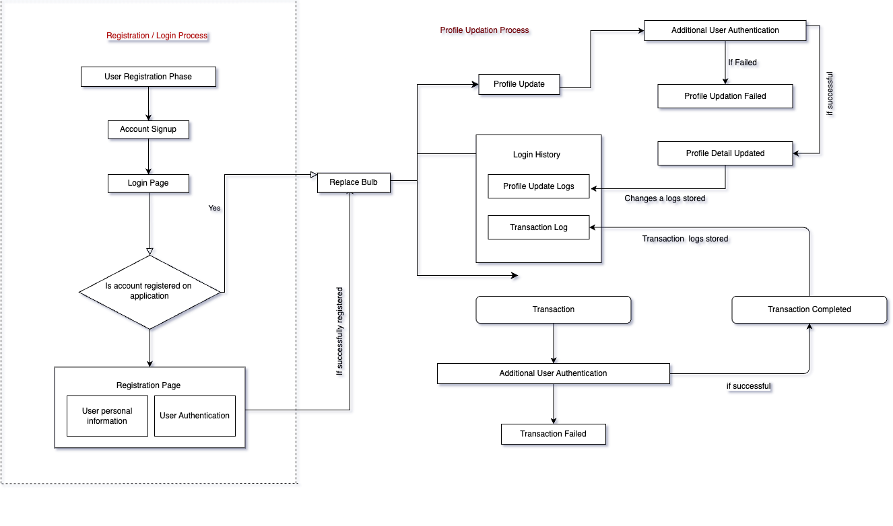

Fig. 4.1: Software Architectural design

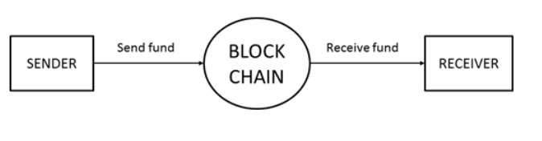

Fig. 4.2: Level 0 Data Flow Diagram

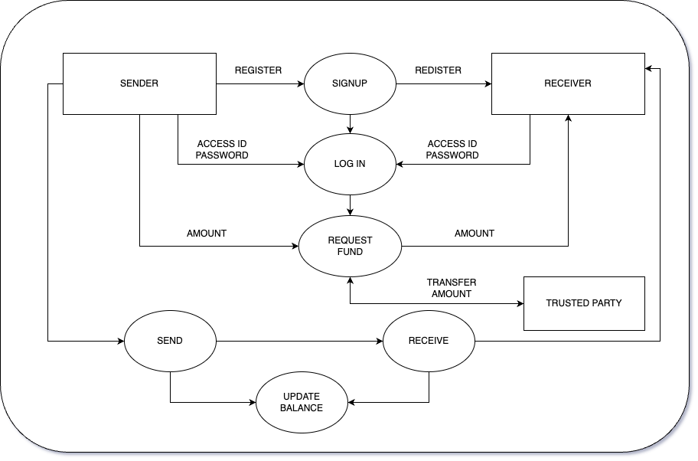

Fig. 4.3: Level 1 Data Flow Diagram

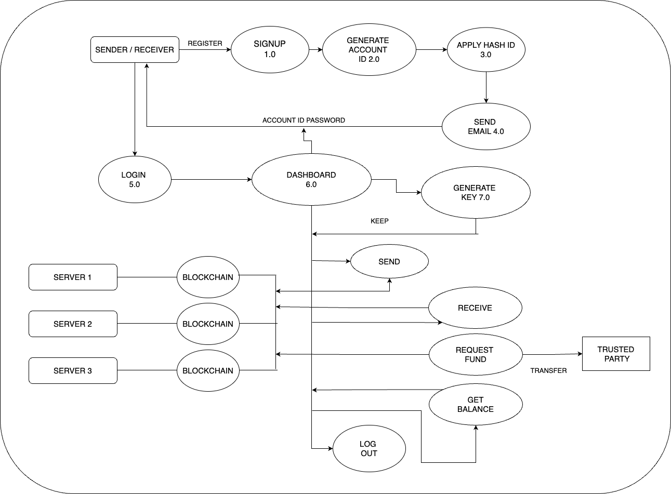

Fig. 4.4: Level 2 Data Flow Diagram

**Data Flow Diagram (DFD)**

**External Entities:**

* User: Initiates the transaction.
* Blockchain Network: Processes and verifies the transaction.

**Processes:**

* Transaction Initiation: User requests a transaction (e.g., fund transfer).
* Blockchain Validation: Blockchain network verifies the transaction details.
* Transaction Confirmation: Once verified, the transaction is confirmed and added to the blockchain.

**Data Stores:**

* Blockchain Ledger server : Stores transaction records in a decentralized manner.

**Data Flows:**

* Transaction Data: Flows from the user to the blockchain network for validation.
* Verified Transaction: Flows back from the blockchain network to the user, confirming the transaction's completion.

# 

# CHAPTER 5

# DESIGN

**5.1 Class Diagram**

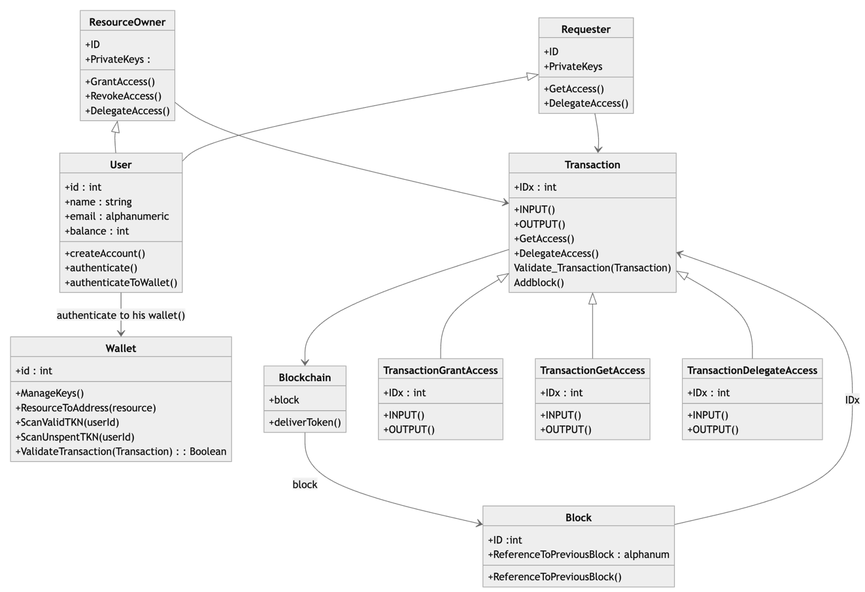

**Explanation of Classes:**

User: Represents a user in the banking system. Users can create accounts and authenticate themselves.

Account: Represents a bank account owned by a user. It supports operations like deposit and withdrawal.

Transaction: Represents a transaction between two accounts. It includes methods for validation and execution.

Block: Represents a block in the blockchain, containing a list of transactions. It includes methods for calculating the hash, adding transactions, and mining the block.

Blockchain: Represents the entire blockchain. It includes methods for creating the genesis block, adding new blocks, and validating the blockchain.

**5.2 Use Case Diagram**

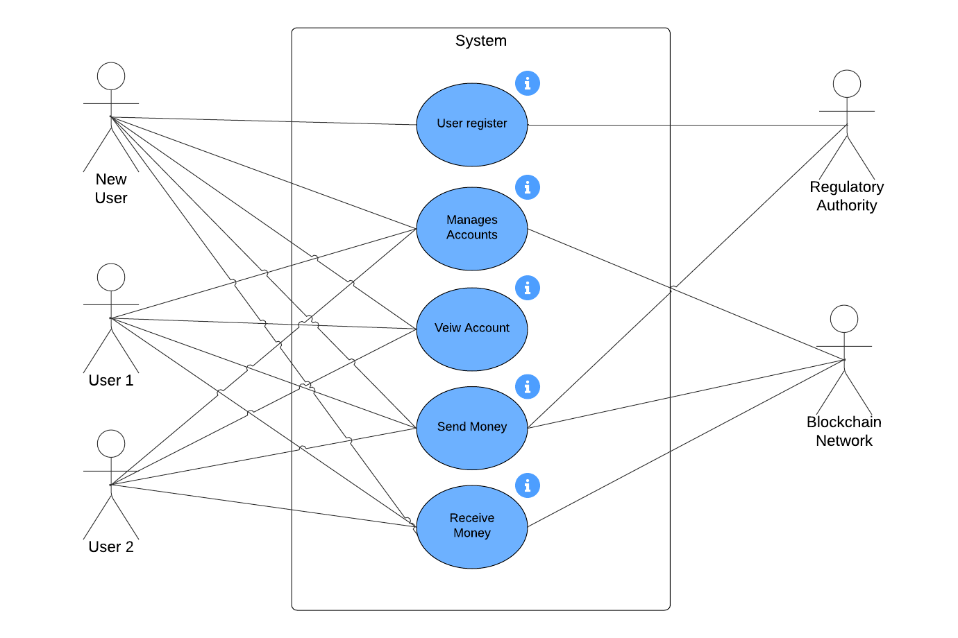

Fig. 5.1: Use case diagram

**Use Case Diagram** :

1. **Actor:**
   * **User**: Interacts with the banking system.
   * **Blockchain Network** : Manages blockchain network for system
   * **Authority** : Security Management for system
2. **Use Cases:**

* **Manage Accounts**
  + - **Create Account**: Customer can create a new account.
    - **View Account Details**: Customer can view account balance, transaction history, and statements.
    - **Update Account Information**: Customer can update personal information and account settings.

1. **Perform Transactions**
   * **Initiate Transaction**: Customer can initiate various transactions like transfers, payments, and withdrawals.
   * **Verify Transaction**: Customer verifies and confirms transactions.
   * **Track Transaction Status**: Customer can track the status of transactions (pending, confirmed, completed).
2. **Transfer Funds**
   * **Internal Transfers**: Customer can transfer funds between accounts within the same bank.
   * **External Transfers**: Customer can transfer funds to accounts in other banks, domestic or international.
   * **Recurring Transfers**: Customer can set up recurring transfers with specified frequencies and amounts.
3. **Manage Security**
   * **Authenticate User**: Customer undergoes authentication for secure login.
   * **Monitor Account Activity**: System monitors and alerts customers of any unusual account activity.
   * **Ensure Data Privacy**: System ensures the privacy and security of customer data.
4. **Administer System**
   * **Manage User Roles**: Admin can manage user roles and access levels.
   * **Generate Reports**: Admin can generate reports for auditing and analysis purposes.
   * **Monitor System Health**: Admin monitors the system for performance and security issues.

**5.2 Activity Diagram**

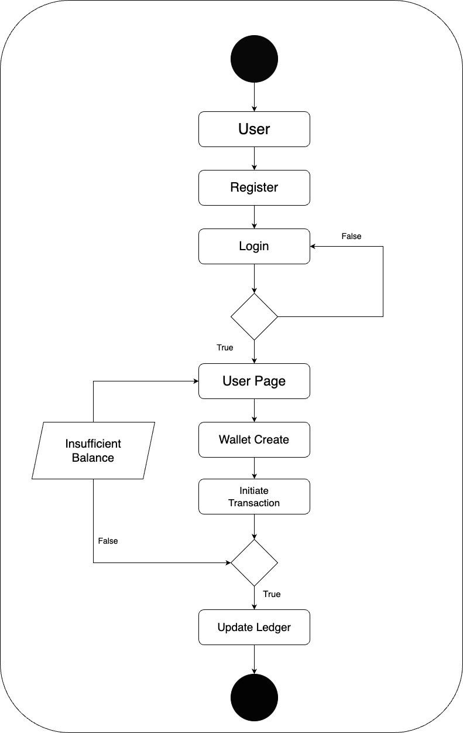

Fig. 5.2: Activity Diagram

Activity Diagram for a system illustrating the process flow:

1. Start:
   * The process begins.
2. Login:
   * User logs into the banking system with username and password.
3. Authenticate User:
   * System verifies user credentials.
   * If authentication fails, return to login.
   * If successful, proceed to the next step.
4. Provide Transaction Details:
   * User inputs transaction details such as recipient account, amount, etc.
5. Initiate Transaction:
   * User confirms and initiates the transaction.
6. Verify Transaction:
   * System verifies the transaction details.
   * If details are incorrect, return to provide transaction details.
   * If correct, proceed to the next step.
7. Process Transaction:
   * System processes the transaction according to the selected type (e.g., deducts amount for withdrawal, transfers funds).
8. Update Account Balances:
   * System updates the balances of the involved accounts.
9. Generate Transaction guide:

* System generates a receipt confirming the transaction details.

1. Send Transaction Confirmation:

* System sends confirmation to the user.

1. End:

* The process concludes.

**5.3 Sequence Diagram**

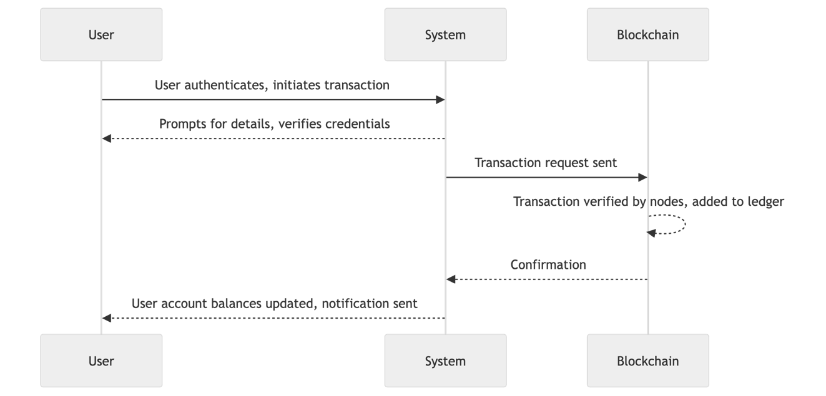

Fig. 5.3: Sequence Diagram

**Sequence Diagram :**

1. User Authentication and Transaction Initiation:

* User logs in to the banking system and selects the option to initiate a transaction.
* Banking system verifies user credentials and prompts for transaction details (e.g., recipient account, amount).

1. Transaction Processing:

* Banking system sends a transaction request to the blockchain network.
* Blockchain network verifies the transaction de tails and broadcasts it to network nodes for validation.

1. Transaction Verification and Confirmation:

* Blockchain network nodes validate the transaction based on consensus mechanisms.
* Once validated, the transaction is added to the blockchain ledger and confirmed.
* Banking system receives confirmation of the transaction status from the blockchain network.

4. Update Account Balances:

* Banking system updates user account balances based on the transaction outcome (e.g., deducting the transfer amount).

5. Notification to User:

* Banking system sends a notification to the user confirming the successful completion of the transaction.

# CHAPTER 6

# SYSTEM IMPLEMENTATION

## 6.1 System Overview

The banking system leverages blockchain technology to ensure secure, transparent, and decentralized transactions. It comprises several components, including the blockchain network, smart contracts, user interface, and backend infrastructure. Blockchain technology and distributed ledger are innovative concepts that have gained significant prominence, particularly in the realm of decentralized systems, cryptocurrencies, and financial transactions. Understanding these concepts requires delving into their underlying principles, functionalities, and the transformative impact they hold.



Architectural design

**System Components:**

1. Blockchain Network:

* Consists of distributed nodes responsible for validating and storing transactions.
* Utilizes consensus mechanisms like Proof of Work or Proof of Stake to achieve agreement on transaction validity.

2. Smart Contracts:

* Self-executing contracts deployed on the blockchain.
* Contains transaction logic and rules governing various banking functionalities such as account creation, fund transfers, and transaction verification.

3. User Interface:

* Web or mobile application enabling users to interact with the system.
* Provides functionalities for account management, transaction initiation, and status tracking.
* Offers a user-friendly experience for accessing banking services.

4.Backend Infrastructure:

* Comprises servers, databases, and APIs responsible for handling business logic and data processing.
* Integrates with the blockchain network to interact with smart contracts and retrieve transaction data.

## 6.2 Modules

**Functional modules design :**

1. **Authentication Module :** User Registration & Login Process will be implemented under this module using wallet authentication. If a user provides information that meets the authentication criteria, the user is validated. If the user provides information that does not meet the authentication criteria, the user is not validated and denied.
2. **Profile Details Module :** New users need to fill details including email, mobile number, DOB etc, will be handled by this module.
3. **Transaction Module :** Money Transaction process between user accounts is accomplished using this module the user can send or receive/ request a token from other users on the network. This module also facilitates fast payment for users with the help of QR methodology.
4. **Logs & History Module :** User transaction history will be managed under this module where users can view their entire transaction details including transaction type(Send/Received), transacted to/from, amount, date-time and message.

# CHAPTER 7

# RESULTS AND EVALUATION

**7.1 Results**

**Outline**

The banking industry is transitioning from traditional securities to high-tech securities. By duplicating existing asset transactions on the blockchain, industry has begun to experiment with blockchain. In terms of infrastructure, Blockchain is open source software that enables the real-time movement of digital assets between users on a network.

**Key implementations outlines of the System**

We have taken into consideration the blockchain to implement transactions features for users that demonstrate a significant reduction in asset transfer costs and timeframes on its counterpart conventional banking system.

**Significant project outcomes**

A blockchain based banking system which works on the principle of immutable distributed ledger we aim to improve the current financial system by incorporating blockchain features in our project. By inclusion of a decentralized structure a higher security is ensured making the financial system more secure.

**Project applicability on Real-world applications**

Our project is based on blockchain and finds its applicability in the field of banking sector. The key benefits of Blockchain technology in the banking sector are that it increases efficiency, improves security, provides immutable records, allows for faster transaction times, and eliminates the need for third-party participation, lowering costs. Some of the advantages of using replacing the traditional banking system are:

1. **Faster payments:**

By offering higher security and lower cost of sending payments, banks could introduce this blockchain service to bring new products to the market.

1. **Clearance and settlement systems**

A simple bank transfer needs to bypass a complicated system of intermediaries. Whereas with blockchain enables banks to keep track of all the transactions publicly and transparently.

1. **Blockchain in banking as digital identity verification**

With blockchain, consumers and companies will benefit from accelerated verification processes. Also users will be able to choose how they wish to identify themselves and with whom they agree to share their identity. They will need to register their identity on the blockchain only once.

**Inference**

The problems faced by conventional banks are huge investments that are being made to establish a system to ensure the process of transactions as per an article bybusinessworld**[5]** .But blockchain allows all the information to be stored in one location. This guarantees the dignity and non-repudiation of the stored data. It allows organizations to access the verification information of a specific customer from another organization and thus avoids duplication of data. A simple bank transfer needs to bypass a complicated system of intermediaries such as custodial services before it reaches its destination; this problem is also resolved by the inclusion of blockchain in banking services.

**7.2 Outputs**

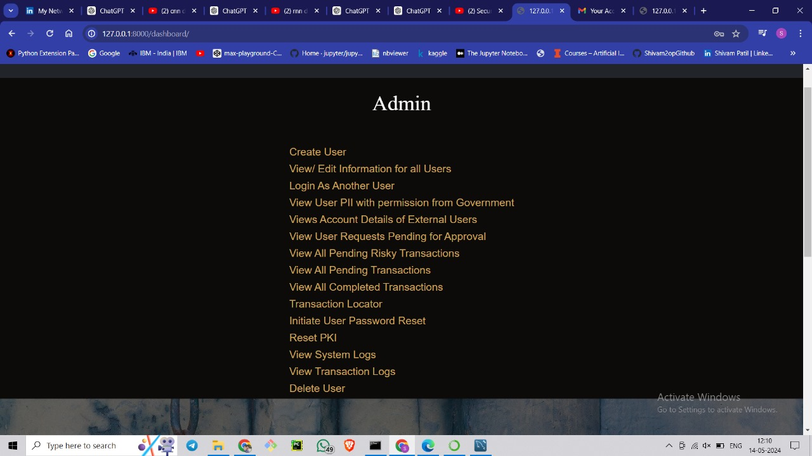

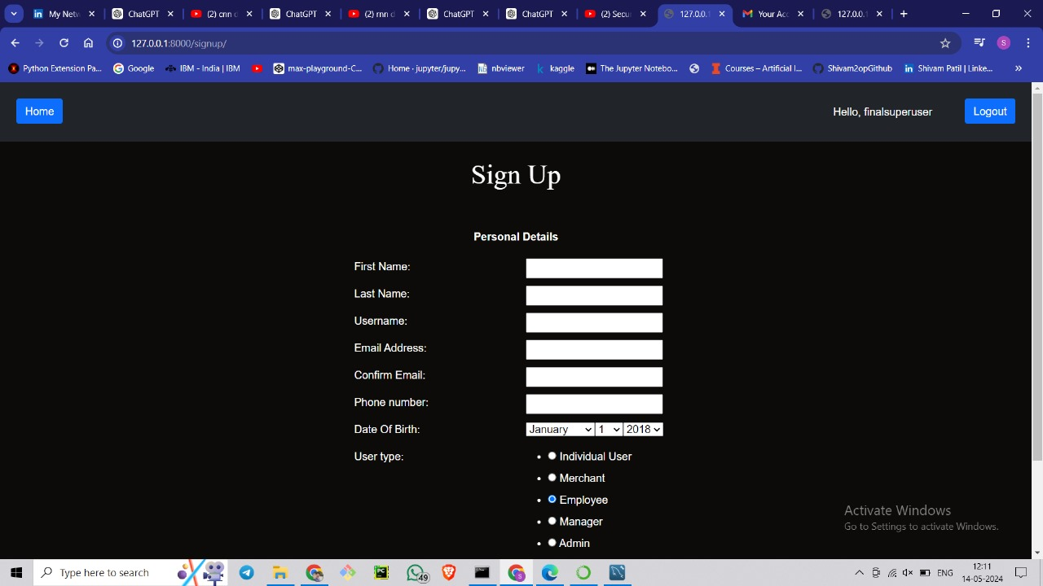

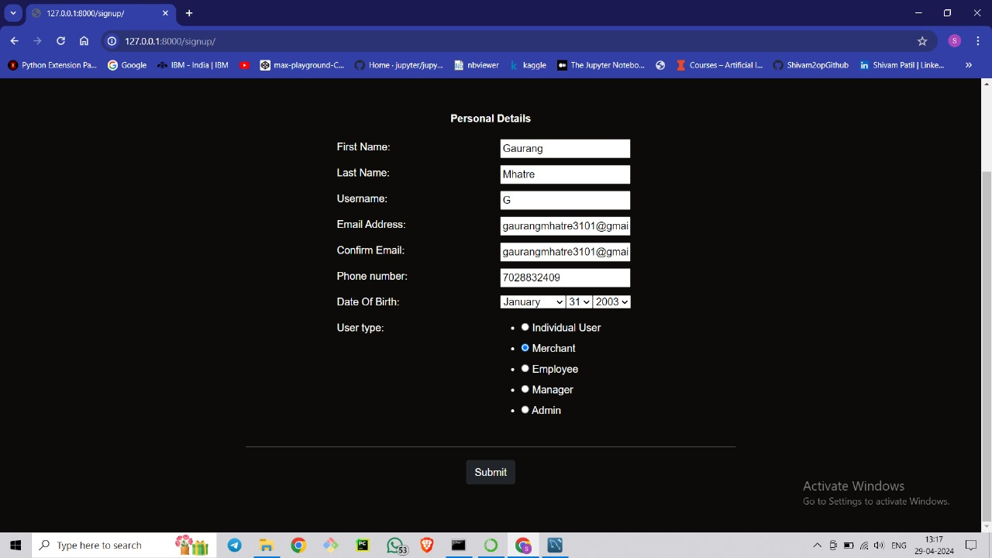

# 

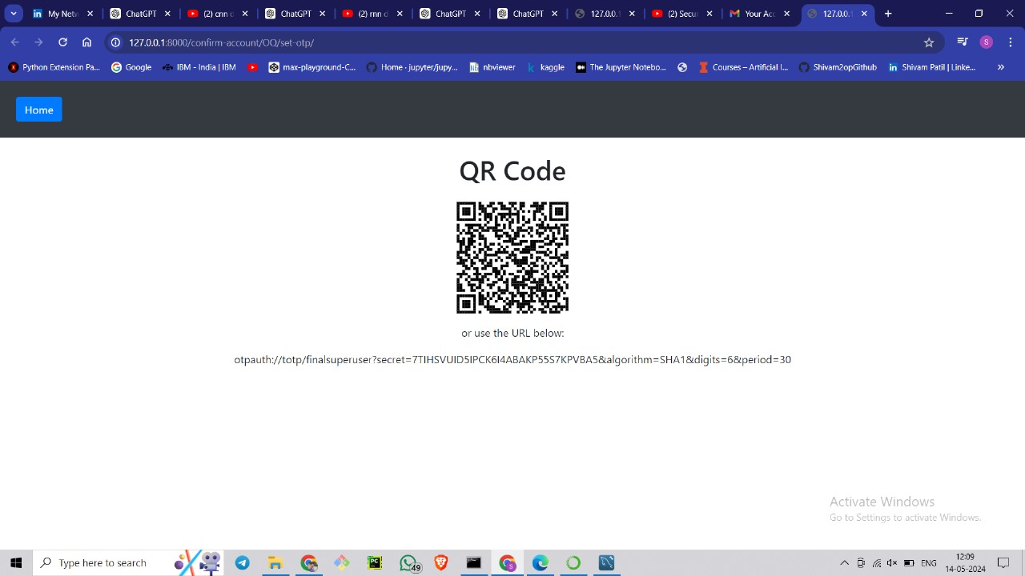

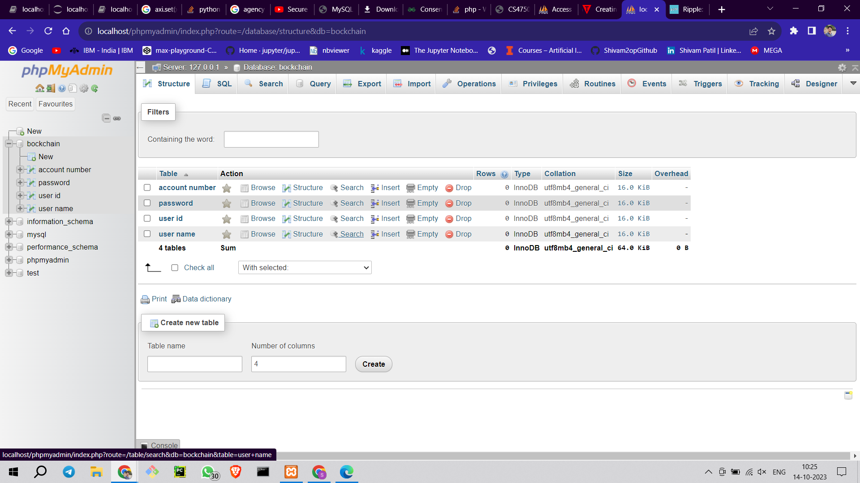

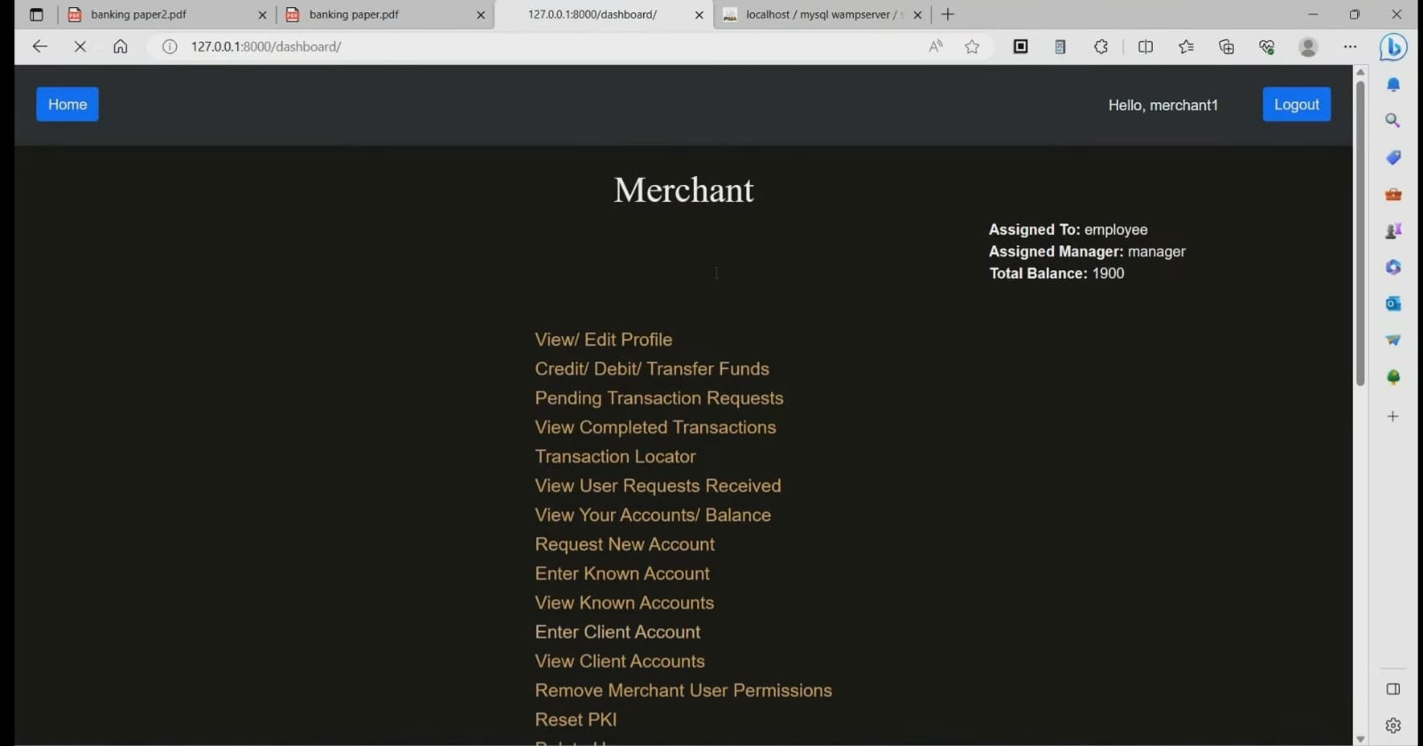

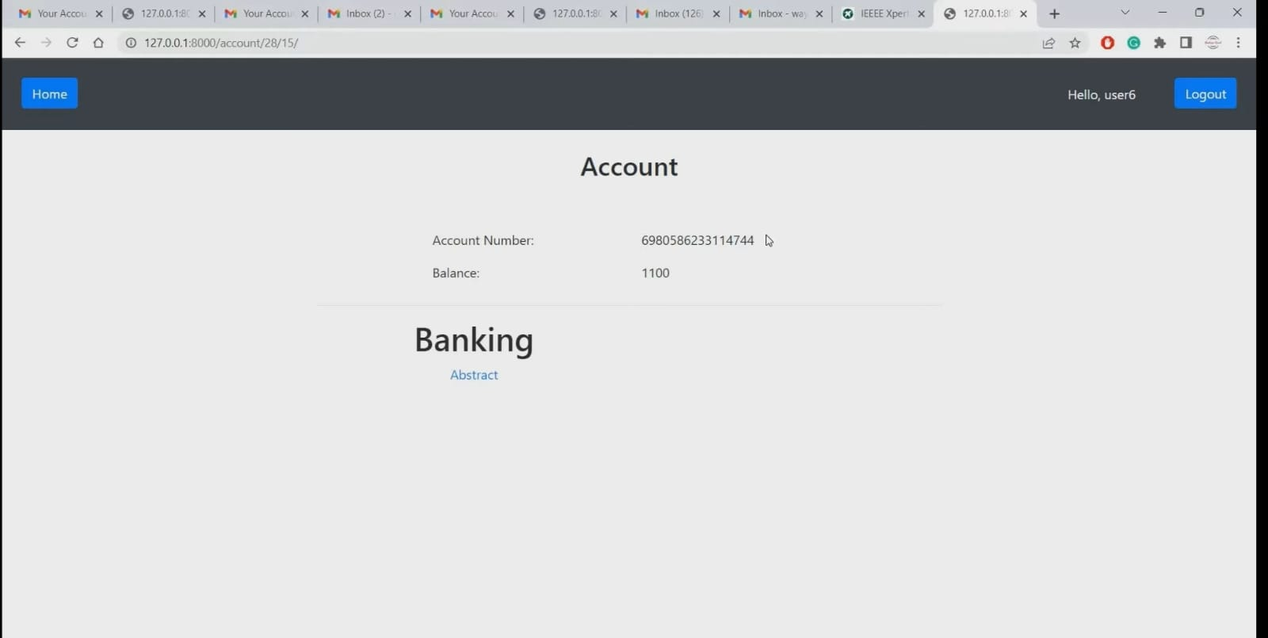

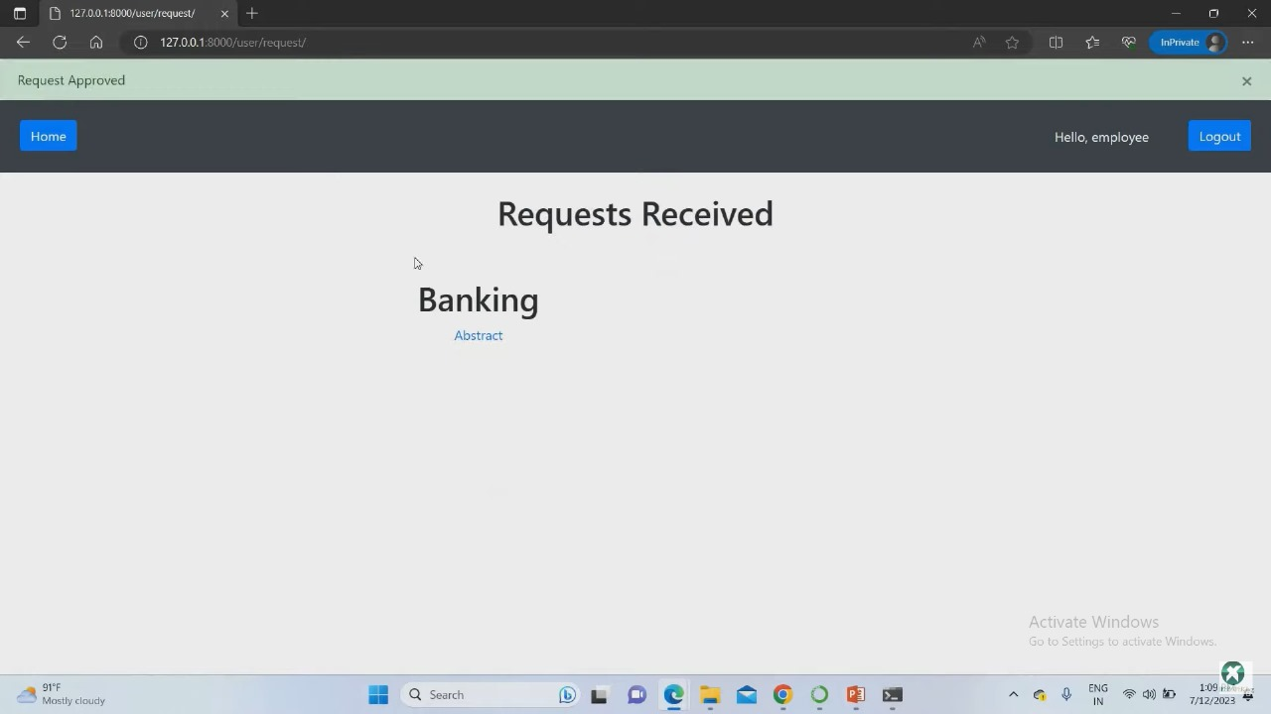

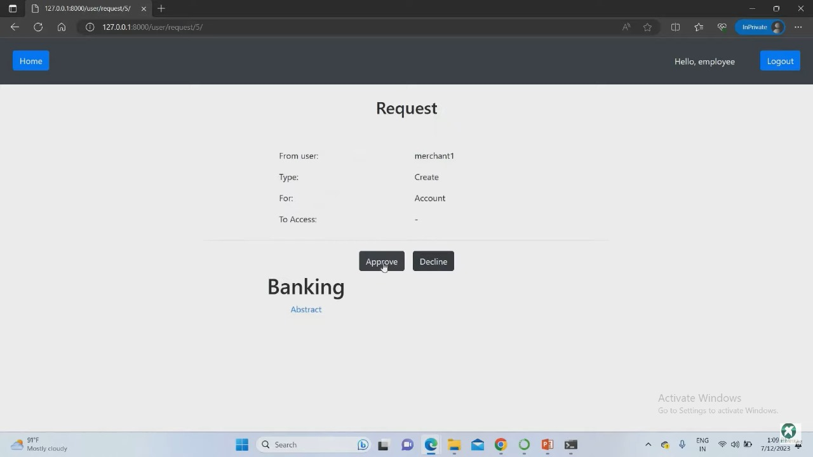

# 

# CONCLUSION

We were able to implement blockchain technology to develop a decentralized, distributed financial system with a transparent token exchange system whilst playing a significant role in accelerating financial inclusion by providing a fast and transparent settlement of transactions. Our system can provide a supportive ecosystem for the private and public banking sector.

We were able to properly execute token transfers across accounts, as well as their pass security. We also designed a mechanism to request tokens from other users and notify them about the same. Moreover, we also designed an easy-to-use token transfer system using QR code creation and scanning. Lastly, we provided users with an interactive user interface and complete transaction logs for its record.

# 

# REFERENCES

1. [[Blockchain application and outlook in the banking industry, Ye Guo and Chen Liang, 2016](https://www.researchgate.net/publication/311549710_Blockchain_application_and_outlook_in_the_banking_industry)
2. [Blockchain Technology and the Financial Services Market, Krause et al., 2017](https://www.researchgate.net/publication/307599627_Blockchain_Technology_and_the_Financial_Services_Market_State-of-the-Art_Analysis)
3. [BlockChain & Financial Inclusion,Prof. Reena Aggrawal, 2017](https://digitalchamber.org/assets/blockchain-and-financial-inclusion.pdf)
4. [Blockchain in banking, Deloitte, 2017](https://www2.deloitte.com/content/dam/Deloitte/in/Documents/strategy/in-strategy-innovation-blockchain-in-banking-noexp.pdf)
5. [Block Chain Technology its use in Banking Sector-S Ravi - BW Businessworld](https://www.businessworld.in/article/Block-Chain-Technology-its-use-in-Banking-Sector/26-10-2020-335662/)

# Appendix A

**Plagiarism Report**

Table 7.2: Plagiarism Report

|  |  |  |
| --- | --- | --- |
| Sr. No | Chapter Name | Plagiarism Percentage |
| 1. | Introduction | 2% |
| 2. | Background and literature Survey | 5% |
| 3. | Requirement and Analysis | 0% |
| 4. | System Architecture | 0% |
| 5. | Design | 1% |
| 6. | Implementation | 0% |
| 7. | Results and Evaluation | 0% |

**Appendix B**

Table 7.3 Test Cases

|  |  |  |  |
| --- | --- | --- | --- |
| **Description** | **Expected Result** | **Actual Result** | **Status** |
| Verify that the user can register an account | User account is successfully created | User account created successfully | Pass |
| Verify that the user can log in with valid credentials | User is logged in to the system | User successfully logged in | Pass |
| Verify that the user cannot log in with invalid credentials | User receives an error message | Error message displayed for invalid credentials | Pass |
| Verify that the user through email | Email send to user of QR code | Email send successfully | Pass |
| Verify that the user can scan QR code | QR Code is generated successfully | QR Code generated successfully | Pass |
| Verify that the user can send money to receiver | Money send to receiver successfully | Receiver gets money successfully | Pass |
| Verify that the user balance updated | User balance updated successfully | Balance updation successfully | Pass |
| Verify that the user able to logout | Logout  successfully | User able to logout successfully | Pass |

**Appendix C**

**Published Papers**

**CERTIFICATES:**

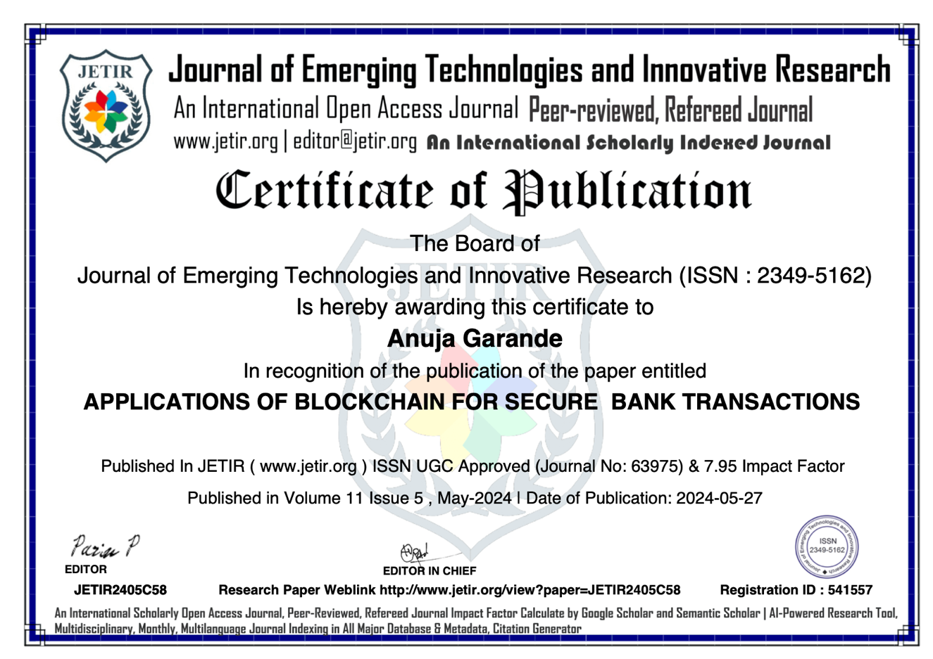



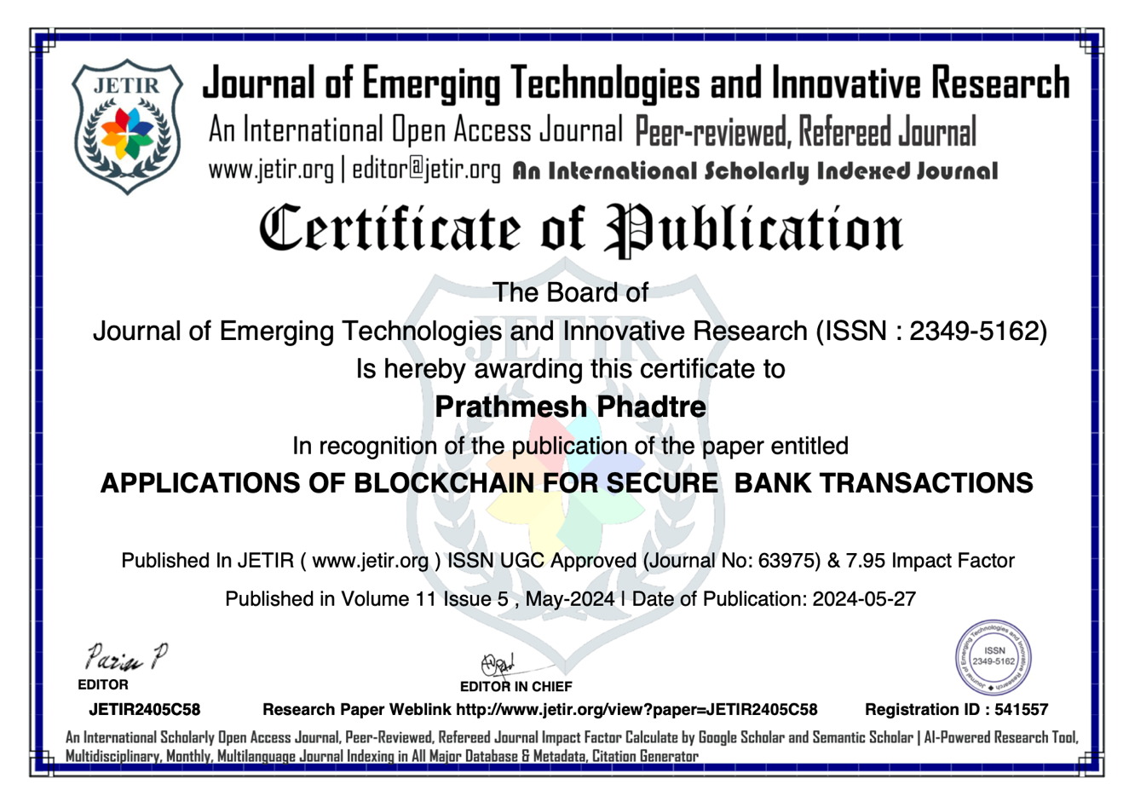

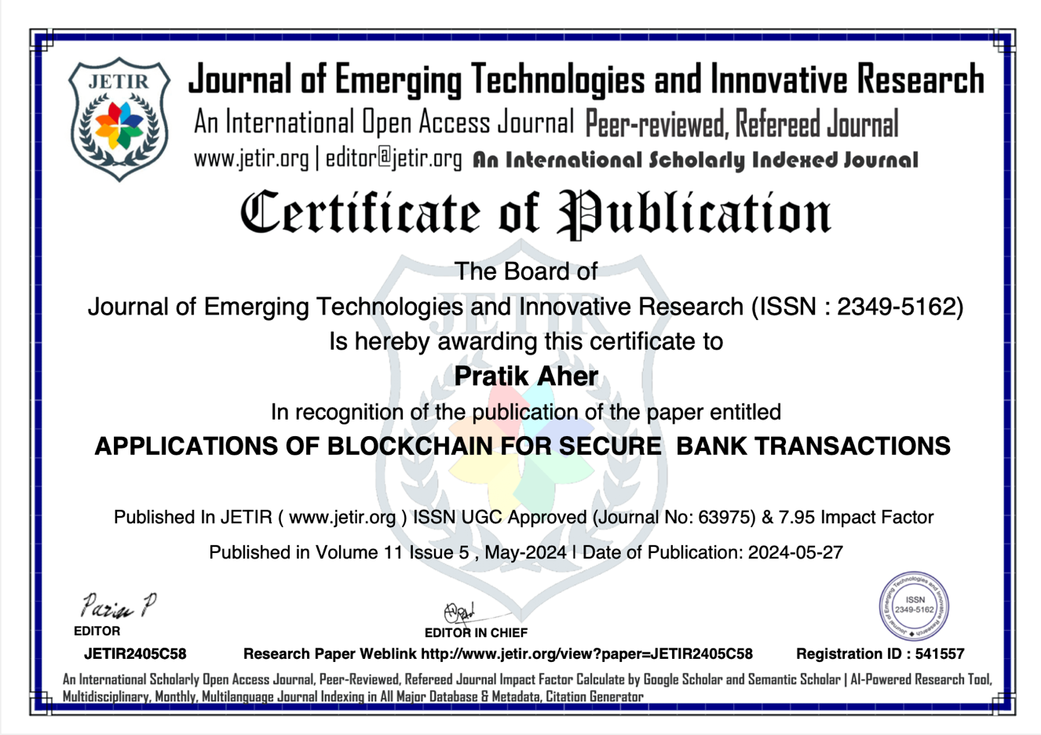

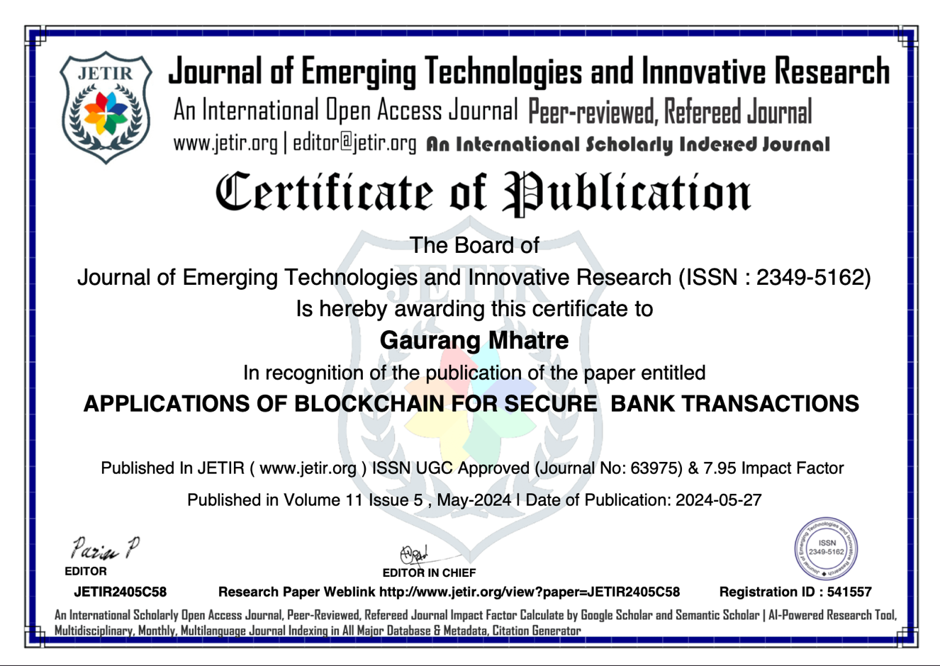

**Report Documentation:**

AIDS-BE-Project 2023-2024

Report Code:

Report Number:

Report Title: Applications Of Blockchain For Secure Bank Transactions

Address (Details): Narhe, Pune

Name of College: Zeal College of Engineering and Research, Narhe, Pune

Authors:

Shivam Patil Gaurang Mhatre

Roll: B190532058 Roll: B190532050

E-mail: shivampatilinfo@gmail.com Email :gaurangmhatre3101@gmail.com

Cell No:7038573273 Cell No: 7028474833

Prathmesh Phadtre Pratik Aher

Roll: B190532061 Roll: B190532001

E-mail: prathameshphadtare3307@gmail.com E-mail: aherpratik00@gmail.com

Cell No: 7775854985 Cell No: 9172302744

Year: 2023-2024

Branch: Artificial Intelligence and Data Science

Keywords: Artificial Intelligence (AI), AI tools, AI platform, Music creation, Video creation, Image creation, Code creation, User-friendly

Type of Report: Report Checked By: Report Checked Date:

FINAL

Total Copies: